

**Java Programming**

**Individual Assignment**

Name : NG HO KIT

Student I.D. : TP035012

Intake Code : UCDF1405ICT(SE)

Course Code : AAPP004-4-2-JP

Lecturer Name : Mr. KURUVIKULAM CHANDRASEKARAN ARUN

Due Date : 28th April 2016

Table of Contents

**Assumption** 2

**Sample Output** 3

loginFrame 3

contentFrame 4

contentFrame.supplierEntry 5

contentFrame.itemEntry 6

contentFrame.registerAccount 8

contentFrame.purchaseRequisition 9

contentFrame.displayRequisition 10

contentFrame.purchaseOrder 11

contentFrame.setting 12

**Sample Code** 13

LoginPage.java 13

ContentPage.java 16

SQLite.java 25

**Extra Features** 28

**References** 30

# **Assumption**

ShopMart Sdn. Bhd is one of Kuala Lumpur’s emerging wholesaler engaged in selling family’s everyday needs to various retailers in Malaysia. ShopMart Sdn. Bhd. requested to develop a Purchase Order Processing System to handle their daily transactions. The system should feature everything listed below:

1. Account Management: The user should be able to login to the system using username and password that already existed inside the database. The admin should be able to change manager/staff’s username, password and roles. The admin also should able to add a new user into the system.
2. Inventory Management: The user of the system should be able to add a new item entry into the database.
3. Supplier Management: The user of the system should be able to add a new supplier entry into the database,
4. Purchase Management: The user of the system should be able to add a new purchase requisition and the manager and admin of the system should be able to generate purchase order. The system should be able to display purchase requisition and purchase order.

Besides, the system is expected to finish develop in 3 months of time, and there will be no error occur during the execution of the program. The system is also expected to deliver most of feature requested by the customer.

# **Sample Output**

## loginFrame

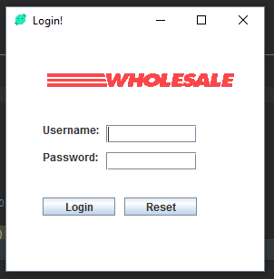

This frame is to allow the user to login into the system by inserting their username and password that existed in the database. If the user tries to login into the system without inserting any details, or try to insert the wrong username and password, an error message will appear to notify the user.

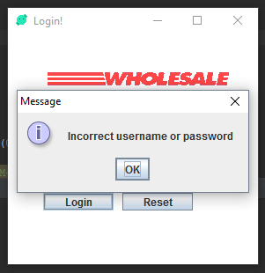

Besides, if the users wish to reset the input field, they can simply press on “Reset” button that available on the frame to reset it.

## contentFrame

Depends on what type of user logged into the system, the frame title and the features will change based on what level of authority the user got. If the users wish to use the features that already implemented into the system, they have to choose the features by pressing the tab on the frame.







Each level of authority possesses different type of features. The higher the level, the more feature they can access on the system.

## contentFrame.supplierEntry

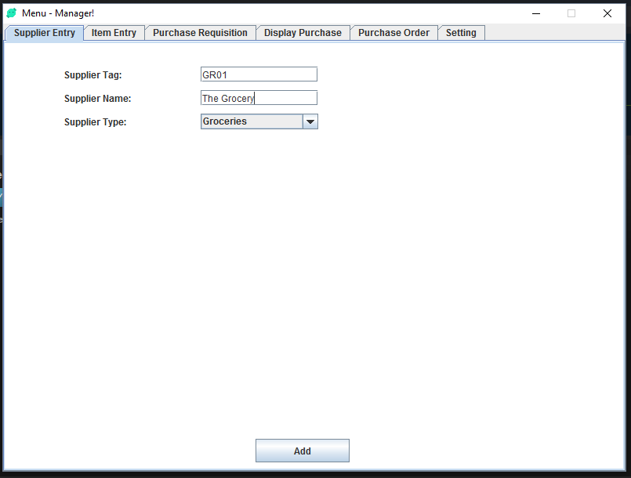

In this panel, user can add a new supplier into the system by inserting their supplier tag, supplier name and supplier type. For example, in the panel, I inserted GR01 for supplier tag, The Grocery for supplier name and Groceries for supplier type then I press on “Add” button. If the supplier tag doesn’t exist in database, then GR01 will be added into the database.

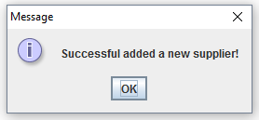

If the supplier already exists inside the database, a message box will notify the user that the supplier already existed inside the database.

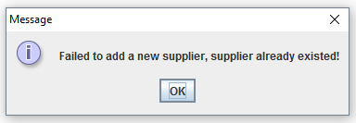

## contentFrame.itemEntry

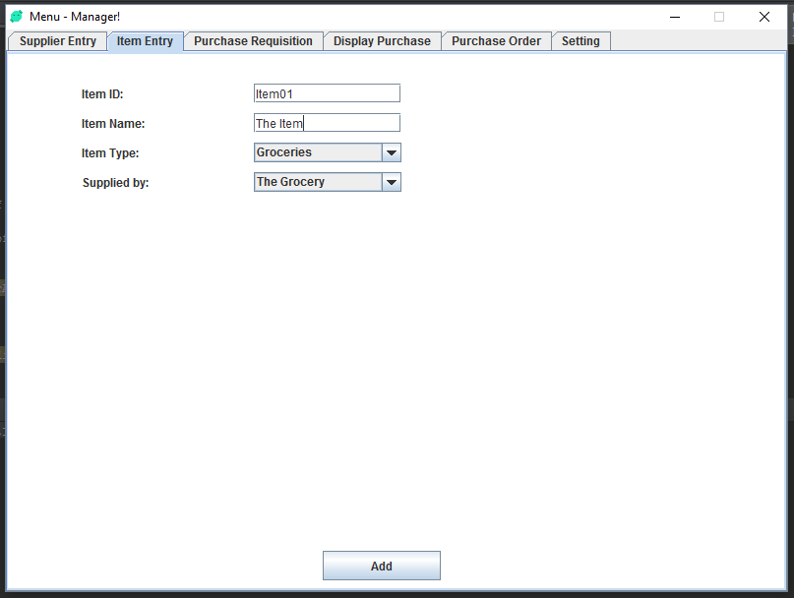

In this panel, user can add an item inside the database by inserting the fields as shown inside the diagram above. The “Supplied by” JComboBox will only show “The Grocery” because we only have “The Grocery” in the database.

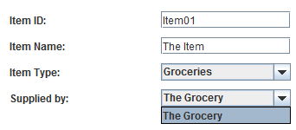

But after the user add another few more supplier, the combobox showing more supplier inside it.

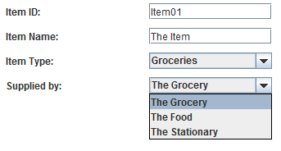

After the user field in everything required, the system will show a messagebox and the data will be stored into the database.

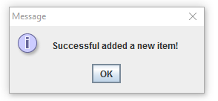

If the user does not fill in the field, a messagebox will appear and ask user to insert something.

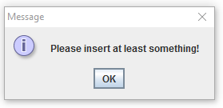

If the user tried to insert the same item id that already existed inside the database, the system will notify the users stating that the item id already existed inside the database.

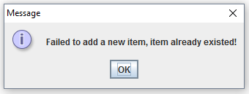

## contentFrame.registerAccount

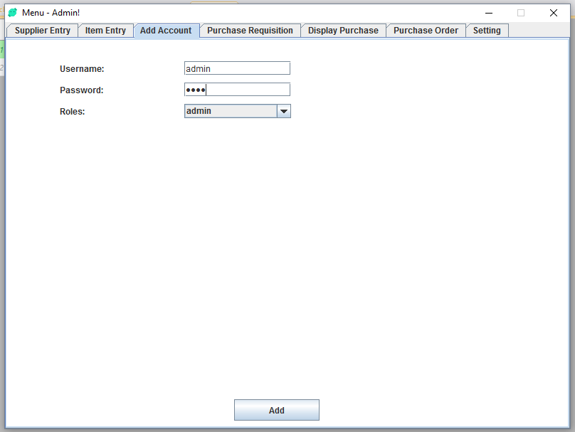

This panel only available if the user logged in as admin. For this panel, admin can register a new account for their staff by inserting the username, password and roles. For roles, user can choose either admin, manager or staff. When admin press on “Add” button, a message box will appear stating that the user already exists, because the username already existed inside the system, if the admin wishes to add a new account, they have to insert a different username. If the new account successfully added into the database, a popup will show that the user successful added a new user.

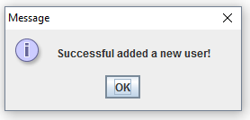

If the admin tried to add a user without inserting the username and password, the system will ask admin to insert at least something.

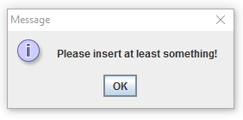

## contentFrame.purchaseRequisition

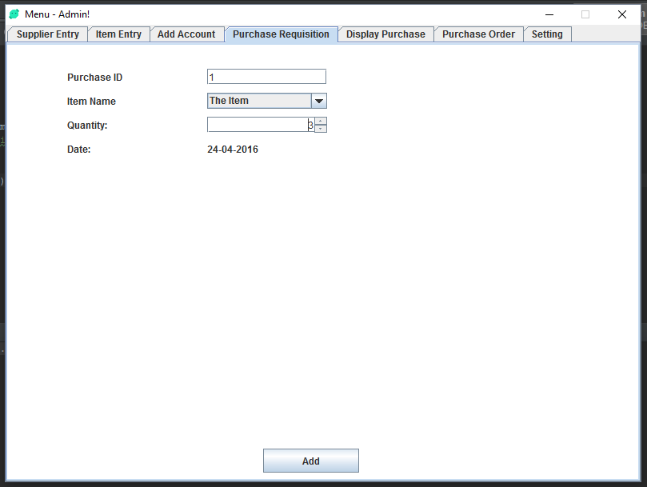

This panel allow users to add purchase requisition by inserting all the field. When the user press on “Add” button the purchase requisition will be added into the database and the data will be show in contentFrame.displayRequisition.

## contentFrame.displayRequisition

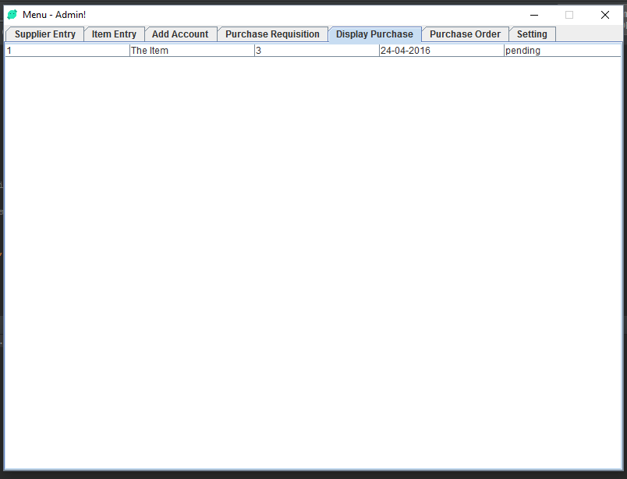

In this panel, purchase requisition and purchase order will be displayed here. By default, when the user added a new purchase requisition, it required the manager or admin to approve the order. Please referring to contentFrame.purchaseOrder to know how it’s work.

## contentFrame.purchaseOrder

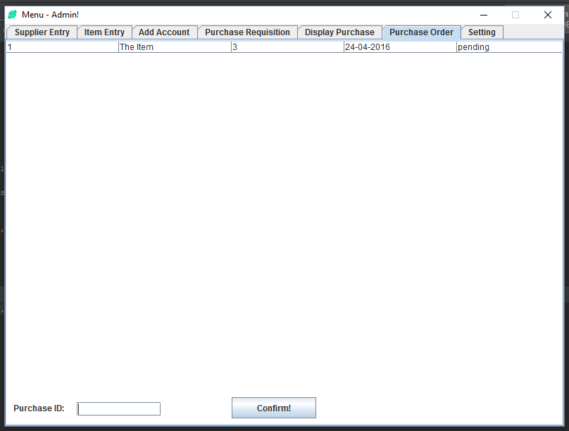

Admin or someone with the access to this panel are able to approve purchase that added by other user by inserting the purchase id. When the user press on “Confirm” button, a messagebox will appear stating that the user successful confirmed the order, then the status will change from “pending” to “confirmed”.

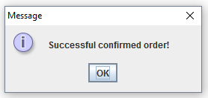

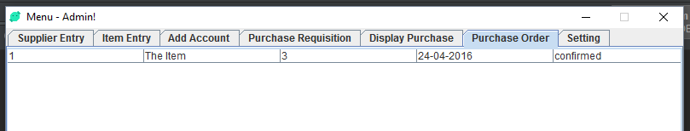

## contentFrame.setting

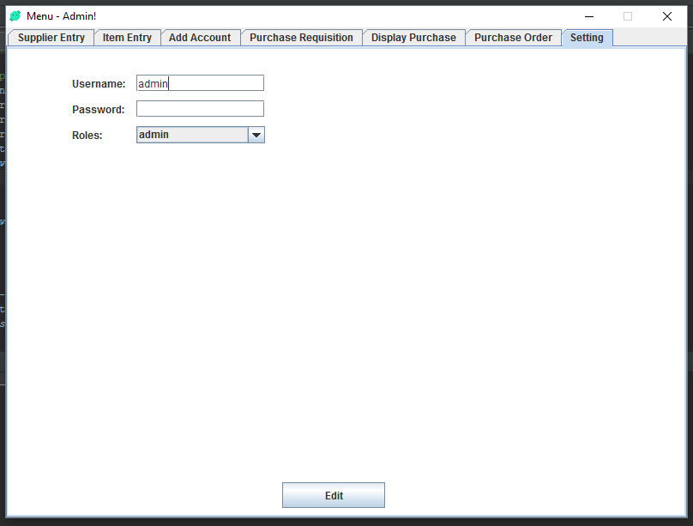

In this panel, user with authority of admin can change their username, password and roles of their own account, admin also can change their staff’s username, password and roles, if the username existed in the database. If user login with the authority level of manager and staff, username and roles field will be disable, which mean they are only allowed to change their password.

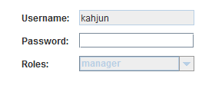

# **Sample Code**

## LoginPage.java

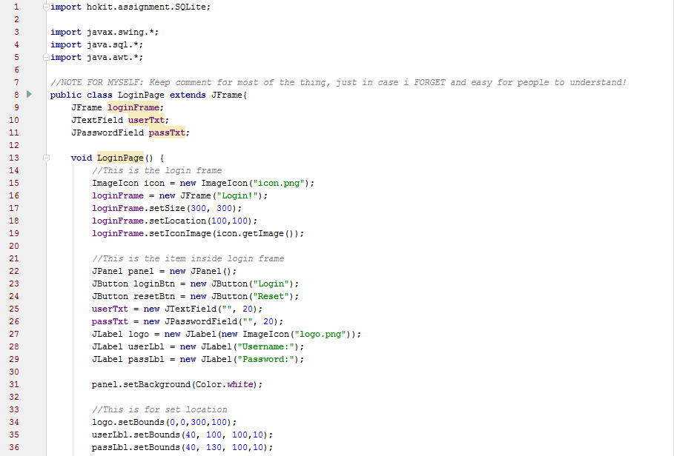

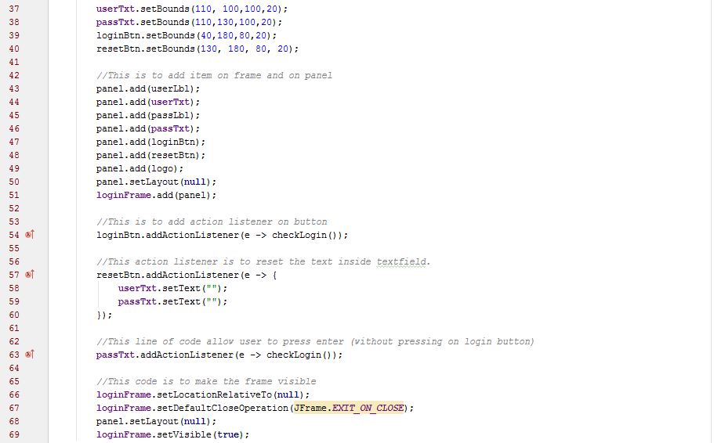  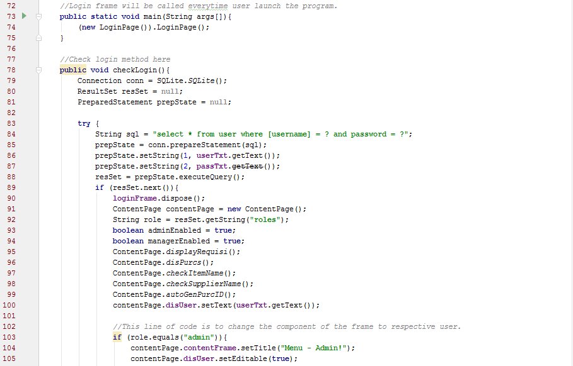

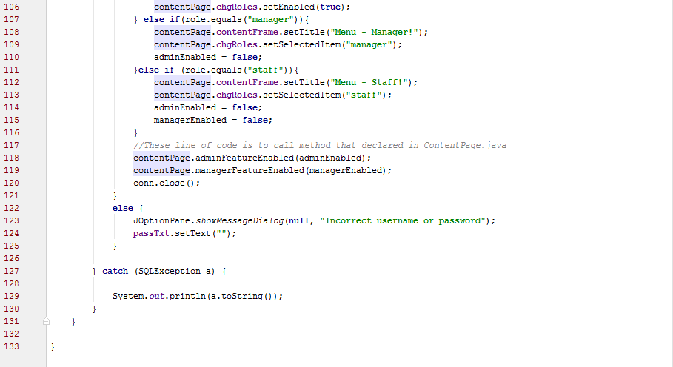

## ContentPage.java

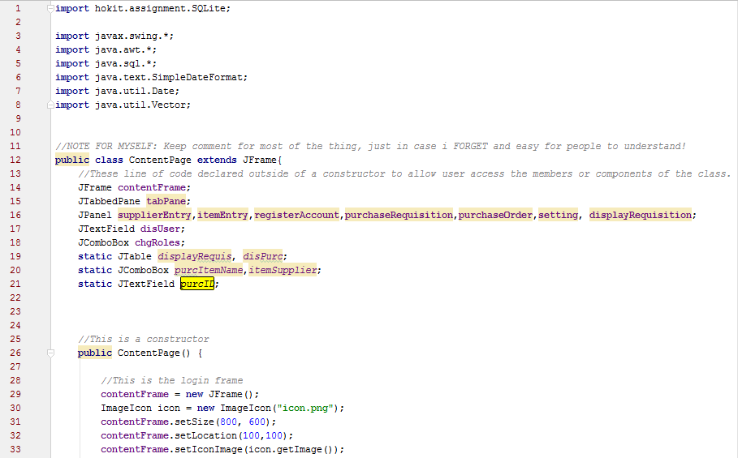 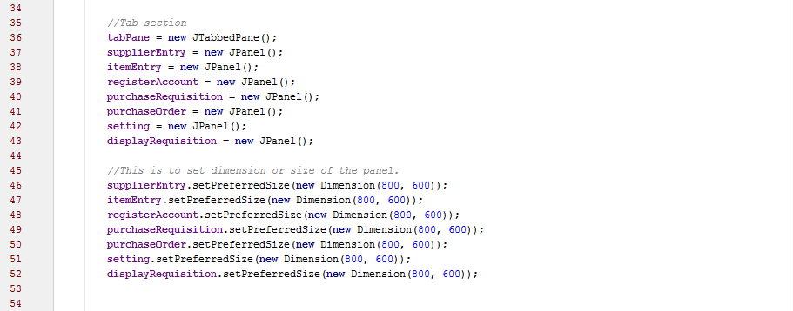

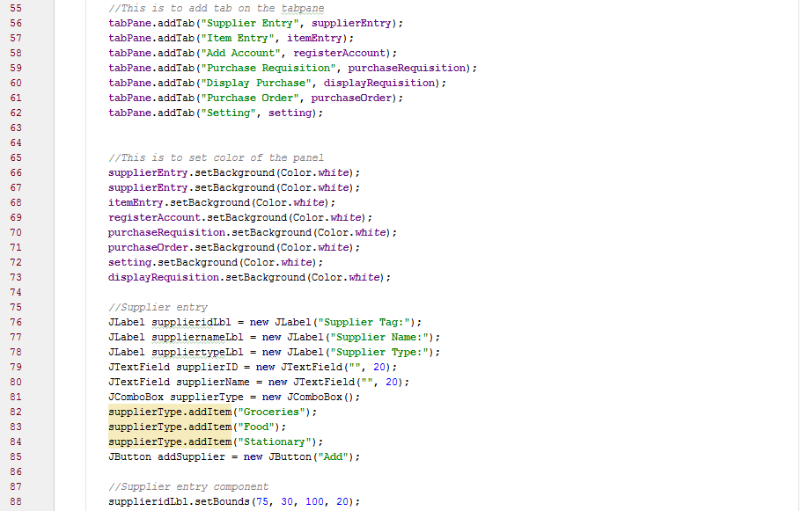 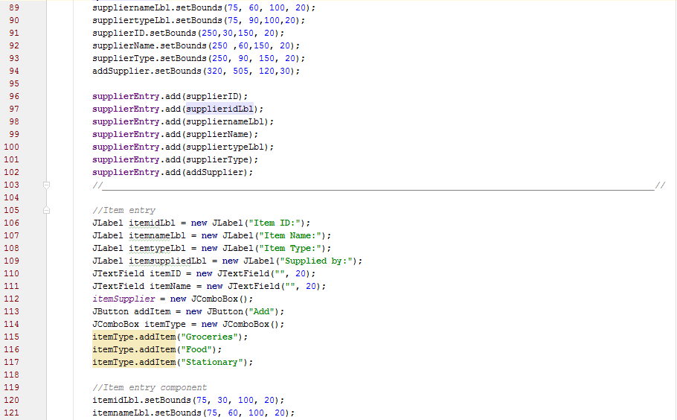

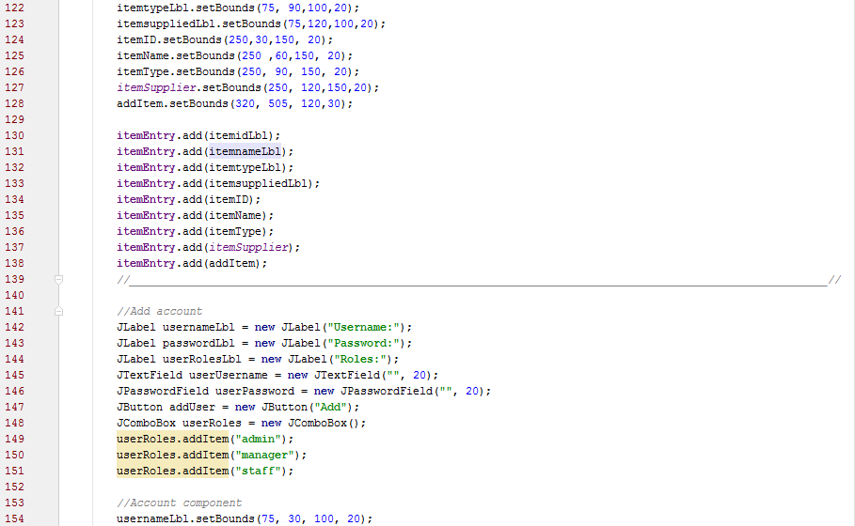 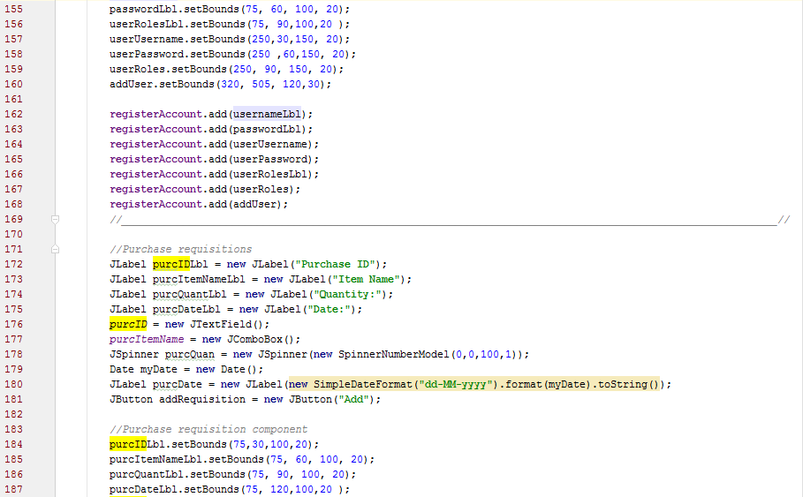

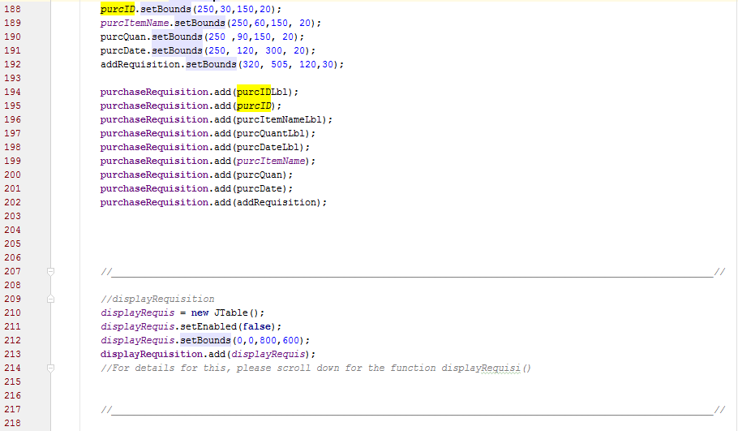 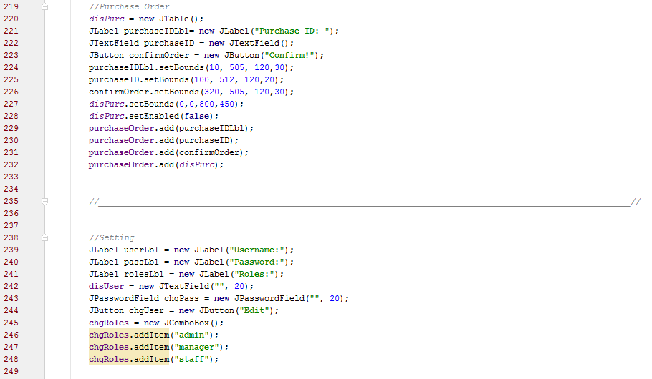 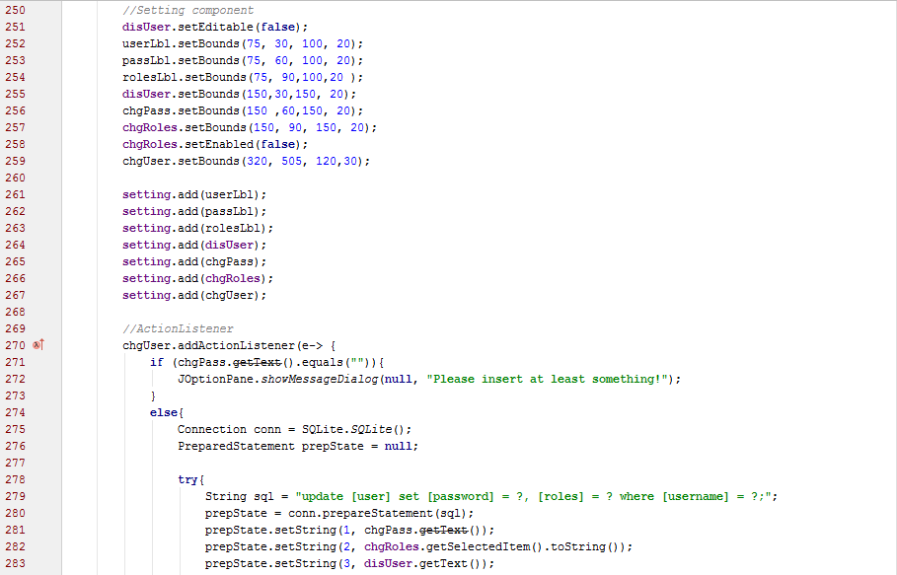 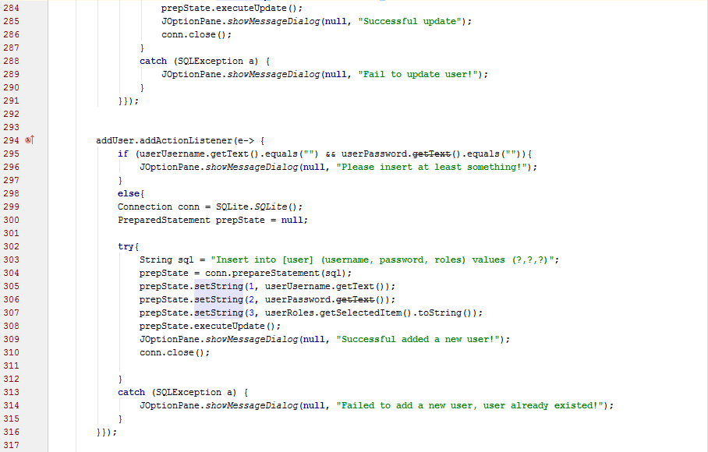 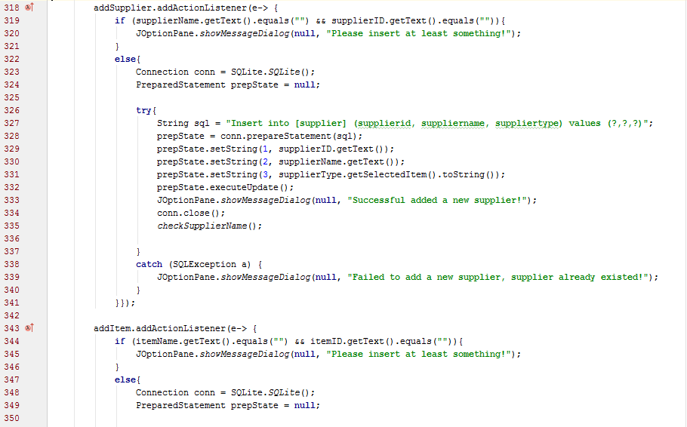 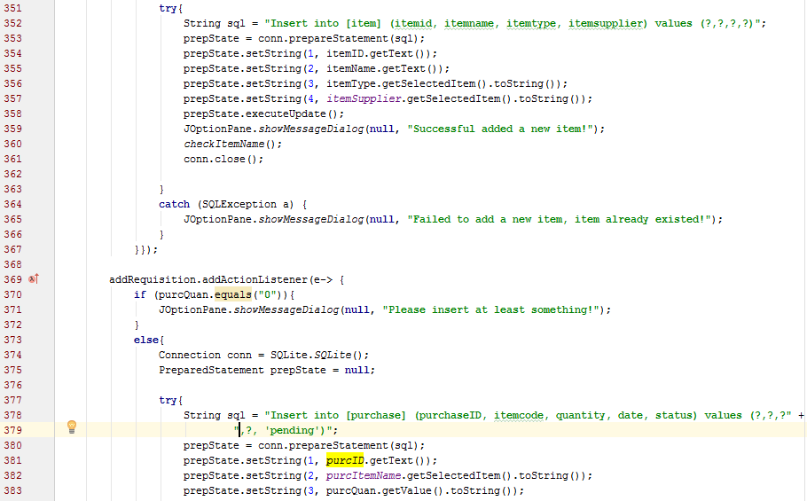 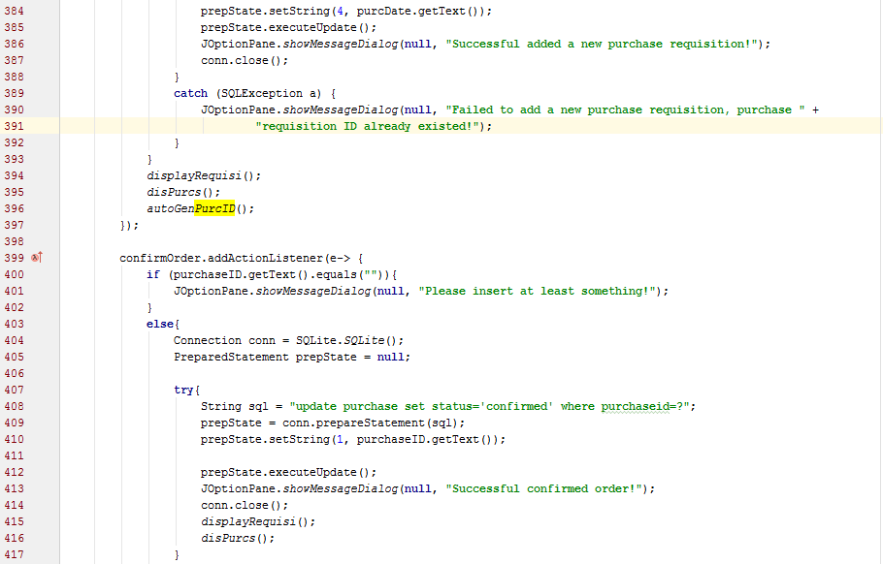 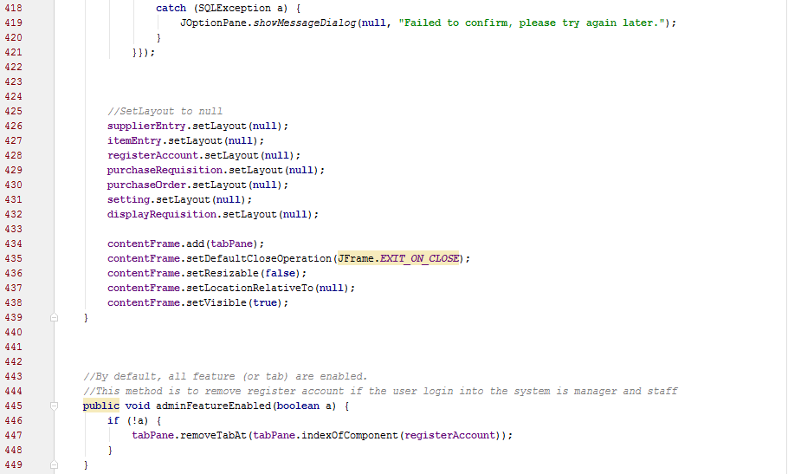 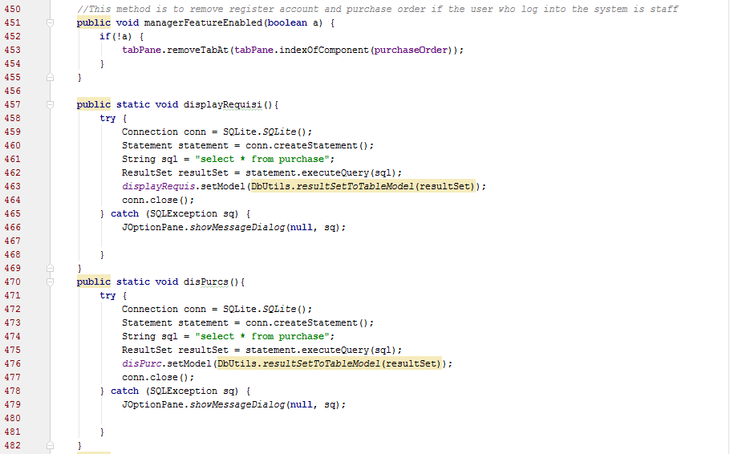 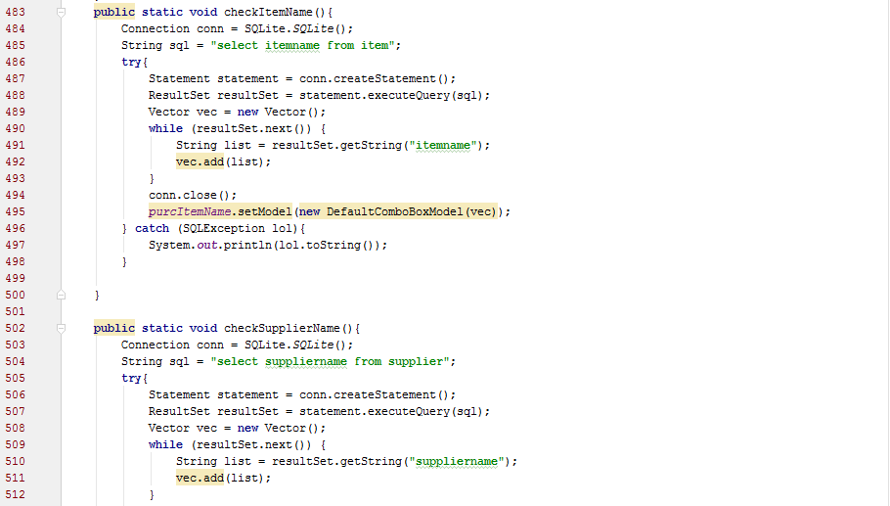

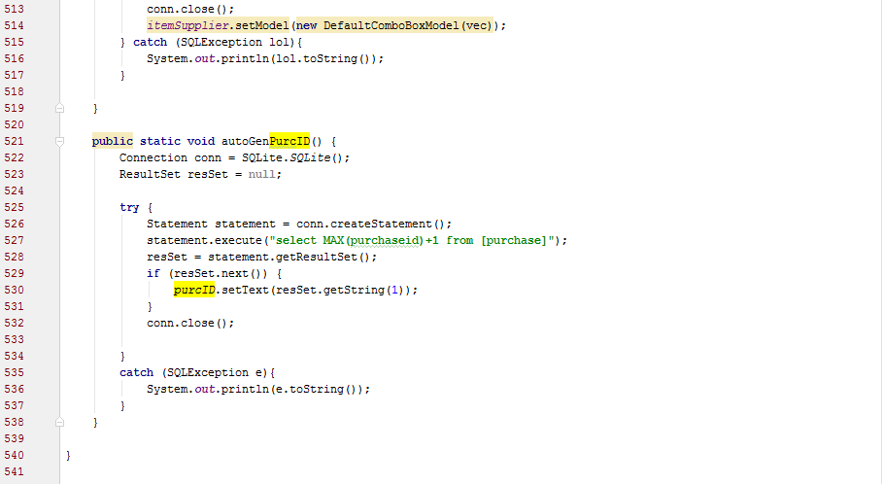

## SQLite.java

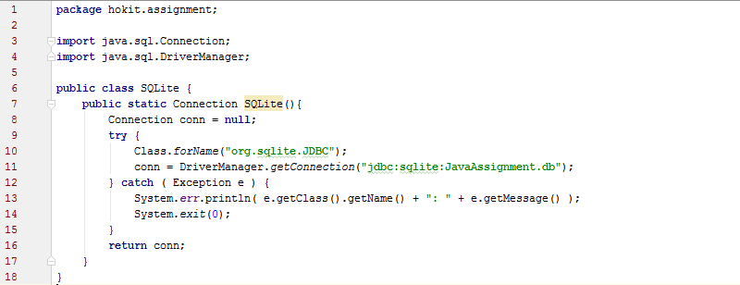

In this system, Object-Oriented Concept used is inheritance, constructor, static class, static method and static variable.

Inheritance:

Inheritance allow user to create a classes that are derived from other classes.



Constructor:

Constructor is a set of code that looks like a method to initialize the object.

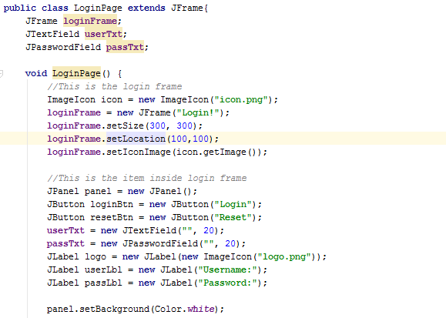

Static Class:

A static class is a nested class which can be accessed without having an object of outer class.



Static Method:

A static method is a method that can be accessed from other class.

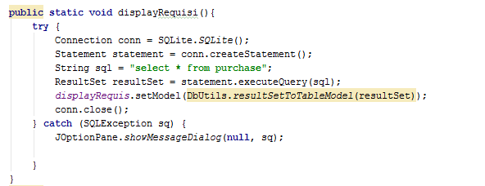

Static Variable:

A static variable is a variable that can be accessed from other class.



# **Extra Features**

1. Some item in JComboBox inside contentFrame are automatically generated from database.

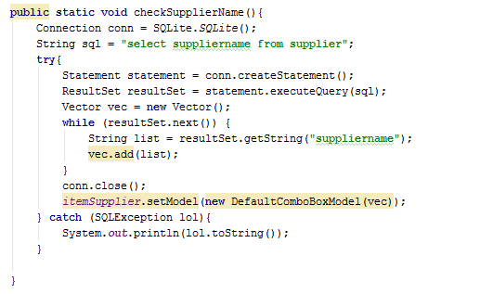

1. User can change their password, admin can change their own username, pass and roles and their manager and staff login information.

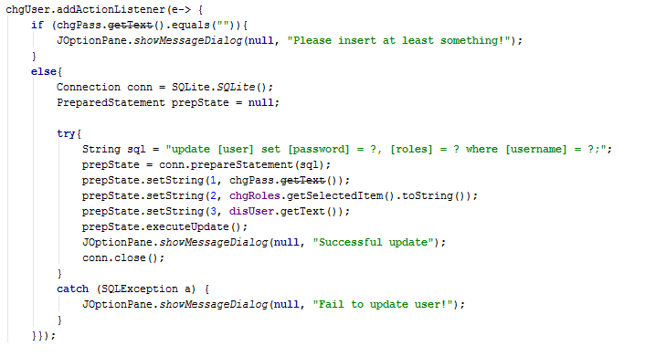

1. Enable and disable features based on what roles they have.

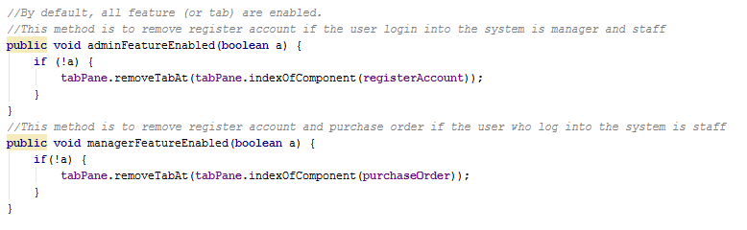 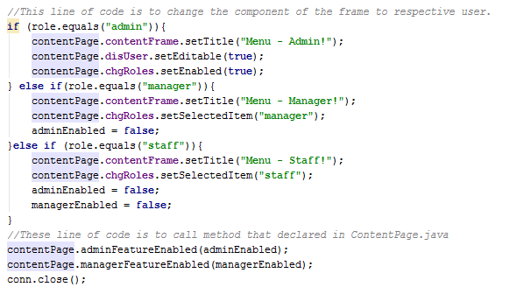

# **References**

Khan, S., 2014. *How to Connect Mysql to Java using JDBC Driver.* [Online]   
Available at: http://learnerarena.com/2014/05/118/  
[Accessed 25 April 2016].

Oracle, 1993. *Java™ Platform, Standard Edition 7.* [Online]   
Available at: https://docs.oracle.com/javase/7/docs/api/  
[Accessed 25 April 2016].

StackOverflow, 2016. *StackOverflow.* [Online]   
Available at: http://stackoverflow.com/  
[Accessed 25 April 2016].

technojeeves, 2016. *ResultSet to TableModel.* [Online]   
Available at: http://technojeeves.com/index.php/22-resultset-to-tablemodel  
[Accessed 25 April 2016].

tutorialspoint, 2016. *Learn Java Programming.* [Online]   
Available at: http://www.tutorialspoint.com/java/  
[Accessed 25 April 2016].